**INDEPENDENT READING, SECOND HALF of BOOK** NAME: ____________________________

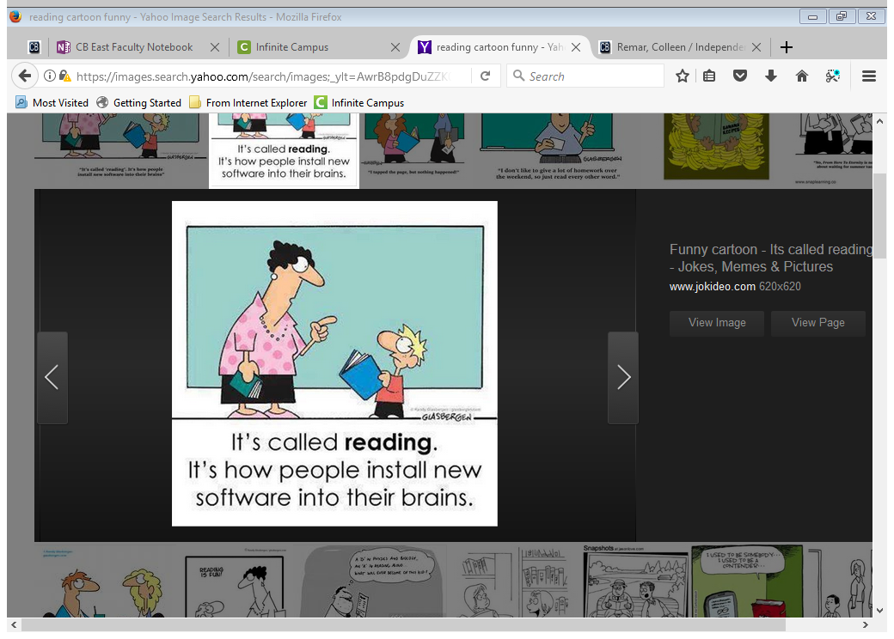

For the second half, you still need to use post its, but you will do so in a scaled-down manner (10 total). As you complete your reading, you only need to look for the literary elements noted below, which will soon help you select evidence for your final project of a Google Doodle. As you re-style the letters of “google” to reflect your book, you will need to pick from specific literary elements. Then, you will need to annotate your letters to explain your visual choices and connect your visual re-creations to your book.

*Make sure post its are in pen and visible when the book is closed.

**FICTION** **POST ITS**

* character
* symbol
* thematic idea
* conflict
* setting
* element of choice (style, POV, allusion, etc.)

**NONFICTION** **POST ITS**

* thematic idea
* important fact/detail
* conflict
* major person who plays a significant role in the text
* reflection of author’s tone, purpose, style, audience, or (un)reliability
* element of choice (POV, tone, audience)

**INDEPENDENT READING, SECOND HALF of BOOK** NAME: ____________________________



For the second half, you still need to use post its, but you will do so in a scaled-down manner (10 total). As you complete your reading, you only need to look for the literary elements noted below, which will soon help you select evidence for your final project of a Google Doodle. As you re-style the letters of “google” to reflect your book, you will need to pick from specific literary elements. Then, you will need to annotate your letters to explain your visual choices and connect your visual re-creations to your book.

*Make sure post its are in pen and visible when the book is closed.

**FICTION** **POST ITS**

* character
* symbol
* thematic idea
* conflict
* setting
* element of choice (style, POV, allusion, etc.)

**NONFICTION** **POST ITS**

* thematic idea
* important fact/detail
* conflict
* major person who plays a significant role in the text
* reflection of author’s tone, purpose, style, audience, or (un)reliability
* element of choice (POV, tone, audience)